Session 1:

Introduction to Databases
& Installation
Solved Tasks • SQL Basics • MySQL Setup • MySQL vs PostgreSQL
Learning goal: Understand what databases are, install/connect to MySQL, create databases, and compare MySQL with PostgreSQL.

Session Concepts

1. What is a database?
A database is an organised collection of information. For example, a music-streaming database may store users, songs, artists, playlists, and listening history.

2. What are RDBMS and SQL?
- RDBMS (Relational Database Management System): software that stores related information in tables made of rows and columns, and manages relationships between those tables.
- SQL (Structured Query Language): the language used to create databases and tables, insert and update data, and ask questions about stored data.

3. Database engines mentioned in the session
Database system | Simple description
MySQL | A widely used open-source relational database, often used by websites and transactional applications.
PostgreSQL | An open-source object-relational database known for SQL features, extensibility, and support for complex data workloads.
Oracle Database | A commercial relational database system used in many enterprise environments.
SQL Server | Microsoft’s relational database system; commonly managed with SQL Server Management Studio (SSMS).

Why SQL is the backbone of analytics
SQL lets analysts retrieve relevant data, combine tables, clean and filter records, calculate totals and averages, group results, and prepare data for dashboards and reports. Tools such as Excel and Power BI often work with data that can be queried or prepared using SQL.

Task 1 — Install MySQL Community Server and capture a screenshot
Answer / steps (Windows):
1. Open the official MySQL Community Server downloads page: https://dev.mysql.com/downloads/mysql/ . Choose the Windows package that matches your system and follow the official installation instructions.
2. Alternatively, for the MySQL 8.0 series, the official MySQL Installer can install MySQL Server and tools such as MySQL Workbench in one wizard: https://dev.mysql.com/downloads/installer/. The official page notes that MySQL Installer is the final installer series for MySQL 8.0; newer server releases use product-specific installers/configurators.
3. Run the installer and follow the prompts. If using MySQL Installer, choose a setup option that includes MySQL Server and MySQL Workbench (for example, Developer Default), if available.
4. Configure the server when prompted. Set and safely remember the root password. Keep the default port unless your setup requires another port.
5. Finish the installation/configuration. Open MySQL Workbench and test the local connection.
Screenshot requirement: You must capture the actual completion window on your own computer. I cannot truthfully provide a screenshot of an installation that has not been performed on your device.
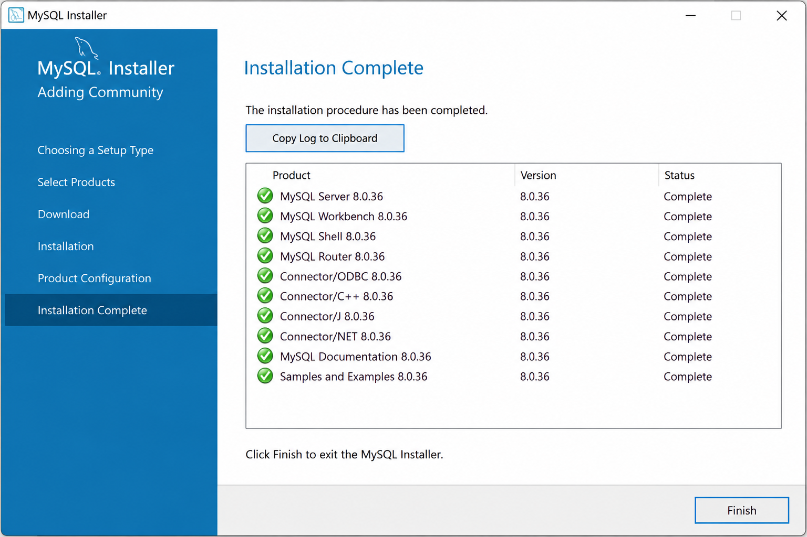
How to take the screenshot: when the installer shows that installation/configuration is complete, press Win + Shift + S, select the completion window, and save or paste the capture here. If the installed version uses a different completion screen, capture the final successful installation/configuration screen.

Task 2 — Connect to MySQL and create music_streaming_db
Use MySQL Workbench (recommended for this task). DB Browser for SQLite is designed for SQLite databases and does not connect directly to a MySQL Server.
1. Open MySQL Workbench.
2. Click your local MySQL connection (often named Local instance MySQL). Enter the root password when requested.
3. Open a new SQL query tab, type the command below, and click the lightning-bolt Execute button.
4. Run SHOW DATABASES; to confirm that the database appears. Then run USE music_streaming_db; to make it the active database.
CREATE DATABASE music_streaming_db;
SHOW DATABASES;
USE music_streaming_db;

Explanation
- CREATE DATABASE music_streaming_db; creates a new database with that name.
- SHOW DATABASES; lists the databases available on the connected MySQL server.
- USE music_streaming_db; selects the database for subsequent commands in the current session.

Task 3 — Create food_delivery_db
SQL command:
CREATE DATABASE food_delivery_db;

To verify and select it, run:
SHOW DATABASES;
USE food_delivery_db;

Explanation: CREATE DATABASE creates the database, SHOW DATABASES verifies that it is listed, and USE selects it as the current database. Execute these statements in MySQL Workbench after connecting to the server.

Task 4 — Three differences between MySQL and PostgreSQL
Comparison | MySQL | PostgreSQL
1. Database model | Commonly described as a relational DBMS. It is widely used for web applications and transactional workloads. | An object-relational DBMS, combining relational tables with additional object-relational capabilities.
2. Data types and extensibility | Supports common numeric, text, date/time, spatial, and JSON types. | Offers a broad set of types such as arrays, ranges, network addresses, and user-extensible types, functions, and operators.
3. Feature emphasis / use cases | Often selected for website backends, e-commerce, and applications where a practical, widely supported relational database is needed. | Often selected for complex queries, specialised data models, data integrity needs, and extensions such as PostGIS for geospatial work.

These are typical differences and use-case tendencies, not strict limits. Both systems can serve many of the same kinds of applications; the better choice depends on the workload, architecture, operational needs, and team experience.

Popular company/app examples
- MySQL: Spotify is listed among MySQL customers on the official MySQL website. See the MySQL Customers page in the references.
- PostgreSQL: Instagram has publicly documented its use of PostgreSQL in its backend/scale-up story. Large companies may use multiple databases, and their architecture can change over time.

Quick Revision
Command / concept | Remember
Database | An organised collection of information.
RDBMS | Manages relational data stored in tables.
SQL | Used to define, query, and manipulate data.
CREATE DATABASE database_name; | Creates a new database.
SHOW DATABASES; | Lists databases on the connected MySQL server.
USE database_name; | Selects the current database.
MySQL Workbench | A graphical tool for connecting to MySQL Server and running SQL.

Official / supporting references
- MySQL Community Server downloads: https://dev.mysql.com/downloads/mysql/
- MySQL Installer downloads and version note: https://dev.mysql.com/downloads/installer/
- MySQL Installer Guide: https://dev.mysql.com/doc/mysql-installer/en/
- MySQL customers (includes Spotify listing): https://www.mysql.com/customers/
- PostgreSQL: What Is PostgreSQL?: https://www.postgresql.org/docs/current/intro-whatis.html
- PostgreSQL project overview: https://www.postgresql.org/about/
- Instagram and PostgreSQL at scale (EDB article): https://www.enterprisedb.com/blog/instagram-scales-postgres
- AWS comparison: MySQL vs PostgreSQL: https://aws.amazon.com/compare/the-difference-between-mysql-vs-postgresql/

Session 2 : Basic SELECT & FROM
Learning goal: Use SELECT to choose what data to display, FROM to choose the table, AS to rename output columns, and -- to add a single-line comment.

Task 1 — Display All Columns from restaurants
Question: Run a query to select all columns from a table named restaurants.
SELECT * FROM restaurants;

Explanation
- `SELECT` tells SQL what data you want to display.
- `*` means all columns in the table.
- `FROM restaurants` tells SQL to read the data from the restaurants table.
- The semicolon `;` marks the end of the SQL statement.
Result: The query displays every column and every row in `restaurants`, such as restaurant ID, name, city, rating, or any other columns actually stored in that table.

Task 2 — Display Only name and rating
Question: Display only the name and rating columns from zomato_reviews.
SELECT name, rating
FROM zomato_reviews;

Explanation
- `name, rating` lists the two columns to display.
- `FROM zomato_reviews` identifies the source table.
- Because the query names only these two columns, the other columns are not included in the result.
Result: The output has two columns: `name` and `rating`, with rows from `zomato_reviews`.

Task 3 — Rename Output Columns Using AS
Question: Select movie_name and release_year from movies, but display the headings as Title and Year Released.
SELECT
movie_name AS Title,
release_year AS `Year Released`
FROM movies;

Explanation
- `movie_name` selects the movie name column.
- `AS Title` gives that output column the heading `Title`.
- `release_year` selects the release year column.
- `AS` renames the output heading. Backticks around `Year Released` allow the alias to contain a space in MySQL.
- `FROM movies` reads the data from the movies table.
Important: An alias changes the column heading in the query result; it does not rename the actual column stored in the table.

Task 4 — Select All Columns and Add a Comment
Question: Select all columns from products and add a single-line comment explaining the query.
-- Display all columns and rows from the products table.
SELECT * FROM products;

Explanation
- `--` starts a single-line comment in MySQL. SQL ignores the comment when executing the query.
- `SELECT *` selects all columns.
- `FROM products` reads the data from the products table.
Result: The comment explains the purpose of the query, and the SQL statement displays all rows and columns from `products`.

Quick Revision
SQL syntax | Purpose
SELECT * FROM table_name; | Select all columns from a table.
SELECT column1, column2 FROM table_name; | Select only the listed columns.
column_name AS Alias | Give the output column a new heading.
-- comment text | Add a single-line comment.
FROM table_name | Specify which table provides the data.

Session 3 : WHERE Clause & Operators

Session Topics
- WHERE operators: =, <>, >, <, <=, >=
- Logical operators: AND, OR, NOT
Demo: Filter employees with salary > 50000 and in "IT" dept.
Learning goal: Use WHERE to filter rows and use comparison and logical operators to match the conditions in each task.

Task 1
Question: Write an SQL query to select all restaurants from a table named 'restaurants' where the rating is greater than or equal to 4.5.

Answer
SELECT *
FROM restaurants
WHERE rating >= 4.5;

Explanation
- SELECT * displays all columns for each restaurant that matches the condition.
- FROM restaurants tells SQL to read the data from the restaurants table.
- WHERE rating >= 4.5 keeps restaurants whose rating is 4.5 or higher.
- The >= operator means “greater than or equal to”, so a rating of exactly 4.5 is included.
Result: Only restaurants with ratings of 4.5 or above appear in the output.

Task 2
Question: In a table called 'movies', filter and display only the movies released after 2020 and with genre 'Action' using the WHERE clause and AND operator.

Answer
SELECT *
FROM movies
WHERE release_year > 2020
AND genre = 'Action';

Explanation
- SELECT * displays all columns of the matching movie records.
- FROM movies tells SQL to read data from the movies table.
- release_year > 2020 selects movies released after 2020. Movies released in 2020 are not included.
- genre = 'Action' selects rows where the genre is Action.
- AND means both conditions must be true: the movie must be released after 2020 and have the Action genre.
Result: Only movies released in 2021 or later whose genre is Action are displayed.

Task 3
Question: Given a table 'products' with columns (id, name, price, category), write a query to find all products not in the 'Electronics' category or with a price less than 500.

Answer
SELECT *
FROM products
WHERE category <> 'Electronics'
OR price < 500;

Explanation
- SELECT * displays every column for the products that match the condition.
- FROM products reads the records from the products table.
- category <> 'Electronics' selects products whose category is not Electronics. The <> operator means “not equal to”.
- price < 500 selects products whose price is strictly below 500. A price of exactly 500 does not satisfy this condition.
- OR means at least one condition must be true. A product is included if it is not in Electronics, if its price is below 500, or if both are true.
- Example: an Electronics product priced at 450 is included because price < 500 is true. An Electronics product priced at 700 is excluded because both conditions are false.
Important: The question says OR. Using AND instead would change the meaning because both conditions would then need to be true

Task 4
Question: Write an SQL query for a table 'users' to show all users who are NOT from 'Ahmedabad' and have more than 1000 followers.
Hint from the task: Use the NOT operator combined with AND.

Answer
SELECT *
FROM users
WHERE NOT (city = 'Ahmedabad')
AND followers > 1000;

Explanation
- SELECT * displays all columns for the users who match both conditions.
- FROM users reads data from the users table.
- NOT (city = 'Ahmedabad') excludes users whose city is Ahmedabad.
- followers > 1000 selects users with more than 1000 followers. A user with exactly 1000 followers is not included.
- AND means both conditions must be true: the user must not be from Ahmedabad and must have more than 1000 followers.
- Parentheses make it clear that NOT applies to the city comparison.
Assumption: The users table contains the city and followers columns, as implied by the task.

Quick Revision
Comparison operators: = means equal to; <> means not equal to; > means greater than; < means less than; >= means greater than or equal to; <= means less than or equal to.
Logical operators: AND requires all conditions to be true; OR requires at least one condition to be true; NOT reverses a condition.
WHERE clause: Filters rows before they appear in the query result.

Session 4 : Wildcards & Pattern Matching

Session Topics
- LIKE — match a text pattern, such as names ending with 'Cafe'.
- BETWEEN — filter values within a range; both endpoints are included.
- IN — check whether a value matches any value in a list.
- Wildcard % — represents zero or more characters.
Learning goal: Use LIKE, BETWEEN, and IN to filter rows based on text patterns, numeric ranges, and multiple possible values.

Task 1 — Restaurants ending with “Cafe”
Question: Write an SQL query to find all restaurants in a table called Restaurants whose names end with 'Cafe' using the LIKE operator.

SQL Answer
SELECT *
FROM Restaurants
WHERE restaurant_name LIKE '%Cafe';

Explanation
- SELECT * displays all columns for each matching restaurant.
- FROM Restaurants reads records from the Restaurants table.
- LIKE '%Cafe' matches names that end with the exact text 'Cafe'. The % wildcard allows any characters before Cafe.
- Example matches: 'Sunrise Cafe' and 'Green Leaf Cafe'. A name like 'Cafe Central' does not match because it does not end with Cafe.
Note: This query assumes the restaurant-name column is called restaurant_name. If your table uses name instead, replace restaurant_name with name.

Task 2 — Products priced from ₹500 to ₹1,500
Question: In a Flipkart-style Products table, use the BETWEEN operator to select all products with a price between 500 and 1500 rupees.

SQL Answer
SELECT *
FROM Products
WHERE price BETWEEN 500 AND 1500;

Explanation
- SELECT * displays all columns for the products that match the condition.
- BETWEEN 500 AND 1500 selects prices in the range from 500 to 1500.
- The range is inclusive: products priced exactly 500 or exactly 1500 are included.
Note: This query assumes the price column is called price.

Task 3 — Users from selected cities
Question: Write an SQL query to display all users from a Users table whose city is either 'Ahmedabad', 'Surat', or 'Vadodara' using the IN operator.

SQL Answer
SELECT *
FROM Users
WHERE city IN ('Ahmedabad', 'Surat', 'Vadodara');

Explanation
- IN checks whether city matches any value in the list.
- The query returns users whose city is Ahmedabad, Surat, or Vadodara.
- It is a concise alternative to writing several city comparisons joined with OR.

Task 4 — Artists whose names contain “ar”
Question: Given a table called Songs with columns song_name and artist_name, find all songs where the artist_name contains the letter sequence 'ar' anywhere in the name using the LIKE operator. Hint: Use wildcards on both sides of the pattern.

SQL Answer
SELECT song_name, artist_name
FROM Songs
WHERE artist_name LIKE '%ar%';

Explanation
- SELECT song_name, artist_name displays the song title and artist name.
- The pattern '%ar%' finds the sequence 'ar' anywhere in artist_name.
- The % before ar allows any characters before the sequence; the % after ar allows any characters after it.
- Example matches include 'Arijit Singh' and 'Charlie Puth', because their artist names contain the sequence 'ar' (case matching depends on the database collation).

Quick Revision
Operator / Pattern | Purpose | Example
LIKE '%Cafe' | Ends with Cafe | name LIKE '%Cafe'
BETWEEN 500 AND 1500 | Inclusive price range | price BETWEEN 500 AND 1500
IN (...) | Matches any value in a list | city IN ('Ahmedabad', 'Surat', 'Vadodara')
LIKE '%ar%' | Contains ar anywhere | artist_name LIKE '%ar%'

Session 5 : DISTINCT, ORDER BY & LIMIT
Task 1
Question: Write an SQL query using the DISTINCT keyword to find all unique payment methods used in the orders table of a food delivery app database.

SQL Answer
SELECT DISTINCT payment_method
FROM orders;

Easy Explanation
This query displays each payment method used in the orders table only once.
- SELECT payment_method chooses the payment_method column to display.
- DISTINCT removes repeated values from the result.
- FROM orders tells SQL to read the data from the orders table.

Task 2
Question: Query the users table to list all cities where users have registered, but display each city only once and sort the result in alphabetical order (A-Z).

SQL Answer
SELECT DISTINCT city
FROM users
ORDER BY city ASC;

Easy Explanation
This query lists unique cities and arranges them alphabetically from A to Z.
- DISTINCT city removes duplicate city names.
- ORDER BY city sorts the result by city name.
- ASC means ascending order, which is A to Z for text.

Task 3
Question: Write an SQL query to select the top 5 most recent movie bookings from the bookings table, ordered by booking_date in descending order.

SQL Answer
SELECT *
FROM bookings
ORDER BY booking_date DESC
LIMIT 5;

Easy Explanation
This query returns the five most recent bookings by placing the newest booking dates first.
- SELECT * displays all columns from each selected booking.
- ORDER BY booking_date DESC sorts booking dates from newest to oldest.
- LIMIT 5 returns only the first five rows after sorting.

Task 4
Question: From a products table containing Flipkart-style product data (id, name, category, sold_count), write an SQL query to retrieve the 10 products with the highest sold_count, displaying only product name and sold_count, sorted from highest to lowest. Use ORDER BY and LIMIT together.

SQL Answer
SELECT name, sold_count
FROM products
ORDER BY sold_count DESC
LIMIT 10;

Easy Explanation
This query displays the ten products with the largest sold_count values, from highest to lowest.
- SELECT name, sold_count displays only the two requested columns.
- FROM products reads product records from the products table.
- ORDER BY sold_count DESC puts the most-sold products first.
- LIMIT 10 restricts the result to ten products.

Quick Revision
- DISTINCT: Returns unique values only, for example SELECT DISTINCT city FROM users;
- ORDER BY city ASC: Sorts text alphabetically from A to Z.
- ORDER BY sold_count DESC: Sorts numbers from highest to lowest.
- LIMIT 10: Restricts the result to ten rows.

Session 6 : Aggregate Functions

TASK 1 — SUM(): Total Amount Spent on Food Orders
Question: Calculate the total amount spent by users in the food_orders table (order_id, user_id, amount).

SQL Query — Total for Each User
SELECT
user_id,
SUM(amount) AS TotalAmountSpent
FROM food_orders
GROUP BY user_id;

Explanation
- SUM(amount) adds the amount values for the orders belonging to the same user.
- GROUP BY user_id creates one result row for each user.
- TotalAmountSpent is the name given to the calculated total.
This query shows how much each user has spent across their food orders.

If you need one grand total for all users
SELECT SUM(amount) AS TotalAmountSpent
FROM food_orders;

This second version returns one value: the total amount across every row in food_orders.

TASK 2 — COUNT(): Songs Added by Each User
Question: Count how many songs each user has added in spotify_playlists (playlist_id, user_id, song_id).
SELECT
user_id,
COUNT(song_id) AS SongsAdded
FROM spotify_playlists
GROUP BY user_id;

Explanation
- COUNT(song_id) counts the non-NULL song_id values for each user.
- GROUP BY user_id groups the playlist records by user.
- SongsAdded is the output column name for the count.
The result contains one row per user represented in the table. If each row represents one song added, the count gives the number of songs recorded for that user.

TASK 3 — AVG() and ROUND(): Average Movie Rating
Question: Calculate each movie’s average rating in bookmyshow_reviews (review_id, movie_id, rating) and round it to one decimal place.
SELECT
movie_id,
ROUND(AVG(rating), 1) AS AverageRating
FROM bookmyshow_reviews
GROUP BY movie_id;

Explanation
- AVG(rating) calculates the average rating for each movie.
- ROUND(AVG(rating), 1) rounds the average to one digit after the decimal point.
- GROUP BY movie_id calculates a separate average for each movie.
Illustrative example: if a movie’s average rating is 4.267, the displayed AverageRating is 4.3.

TASK 4 — MIN() and MAX(): Smallest and Largest Transaction
Question: Show the minimum and maximum transaction amount for each user in paytm_transactions (txn_id, user_id, amount).
SELECT
user_id,
MIN(amount) AS MinimumTransaction,
MAX(amount) AS MaximumTransaction
FROM paytm_transactions
GROUP BY user_id;

Explanation
- MIN(amount) returns the smallest transaction amount for each user.
- MAX(amount) returns the largest transaction amount for each user.
- GROUP BY user_id calculates these values separately for each user.
If you only want a specific user, add a WHERE condition such as WHERE user_id = 101 before GROUP BY.

TASK 5 — Multiple Aggregate Functions with GROUP BY
Question: For each user in myntra_orders (order_id, user_id, total_price), show the number of orders, average order value rounded to two decimal places, and highest order value.
SELECT
user_id,
COUNT(order_id) AS TotalOrders,
ROUND(AVG(total_price), 2) AS AverageOrderValue,
MAX(total_price) AS HighestOrderValue
FROM myntra_orders
GROUP BY user_id;

Explanation
- COUNT(order_id) counts the orders for each user.
- AVG(total_price) calculates each user’s average order value.
- ROUND(AVG(total_price), 2) rounds the average to two decimal places.
- MAX(total_price) returns that user’s highest order value.
- GROUP BY user_id produces one result row per user.

Final Revision Table
Function | Purpose
SUM() | Adds values together.
COUNT() | Counts rows or non-NULL values.
AVG() | Calculates the average.
ROUND(value, decimals) | Rounds a number to the specified decimal places.
MIN() | Returns the smallest value.
MAX() | Returns the largest value.
GROUP BY | Calculates aggregate results separately for each group.

Key idea: Aggregate functions summarize data. Use GROUP BY when you need the summary separately for each user, movie, or other category.

Session 7 : Group By and Having

Core Concept: GROUP BY and HAVING
GROUP BY collects rows that share the same value, such as the same user_id, payment_method, genre, or another category. Aggregate functions such as COUNT() and SUM() then calculate one result for each group.
Clause / Function | Purpose
GROUP BY | Creates groups of rows that share the same value.
COUNT(*) | Counts the rows in each group.
SUM(column) | Adds numeric values in each group.
WHERE | Filters individual rows before grouping.
HAVING | Filters groups after aggregate calculations.

Easy rule: Use WHERE to filter rows before grouping. Use HAVING when the condition depends on an aggregate such as COUNT() or SUM().

Session Demo — Total Revenue per Region Above 1M
SELECT
region,
SUM(revenue) AS total_revenue
FROM sales
GROUP BY region
HAVING SUM(revenue) > 1000000;

This example assumes a table named sales with columns region and revenue, and the revenue values use the same currency unit. GROUP BY creates one row per region; HAVING keeps only regions whose total revenue is greater than 1,000,000.

Session 8 : Joins: Inner, Left, Right

Join concepts in this session
Join type | What it keeps
INNER JOIN | Only rows that match in both tables.
LEFT JOIN | Every row from the left table, plus matching rows from the right table. No match on the right gives NULL.
RIGHT JOIN | Every row from the right table, plus matching rows from the left table. No match on the left gives NULL.

Task 1 — Create Users and Orders Tables
Create the Users and Orders tables, insert at least three users and five orders, and make sure at least one user has no orders. The sample data also includes an order with user_id = 99, which does not exist in Users; this will help test Task 4.

SQL code
CREATE DATABASE IF NOT EXISTS session8_join_practice;
USE session8_join_practice;
CREATE TABLE Users (
user_id INT PRIMARY KEY,
username VARCHAR(100) NOT NULL,
city VARCHAR(50)
);
CREATE TABLE Orders (
order_id INT PRIMARY KEY,
user_id INT,
product VARCHAR(100),
amount DECIMAL(10,2)
);
INSERT INTO Users (user_id, username, city)
VALUES
(1, 'Ahad', 'Ahmedabad'),
(2, 'Priya', 'Mumbai'),
(3, 'Rahul', 'Surat');
INSERT INTO Orders (order_id, user_id, product, amount)
VALUES
(101, 1, 'Pizza', 250.00),
(102, 1, 'Burger', 150.00),
(103, 2, 'Pasta', 300.00),
(104, 2, 'Sandwich', 120.00),
(105, 99, 'Biryani', 400.00);
SELECT * FROM Users;
SELECT * FROM Orders;

What the code does
- `CREATE DATABASE` creates a separate practice database; `USE` selects it.
- `Users` stores each user’s ID, username, and city. `user_id` is the primary key, so it uniquely identifies each user.
- `Orders` stores each order’s ID, user ID, product, and amount. `order_id` is its primary key.
- Ahad has two orders, Priya has two orders, and Rahul has no orders.
- The order for user_id 99 has no matching user. No foreign key is added to Orders, so this sample can demonstrate the unmatched-order case in Task 4.

Sample data overview
Users | City
Ahad | Ahmedabad
Priya | Mumbai
Rahul | Surat

order_id | user_id | product | amount
101 | 1 | Pizza | 250.00
102 | 1 | Burger | 150.00
103 | 2 | Pasta | 300.00
104 | 2 | Sandwich | 120.00
105 | 99 | Biryani | 400.00

Task 2 — INNER JOIN: Users Who Have Orders
Use INNER JOIN to list usernames and the products they ordered. Only users who have at least one matching order appear in the result.
USE session8_join_practice;
SELECT
u.username,
o.product
FROM Users AS u
INNER JOIN Orders AS o
ON u.user_id = o.user_id
ORDER BY o.order_id;

Explanation
- `Users AS u` gives the Users table the short alias `u`. `Orders AS o` gives Orders the alias `o`.
- `ON u.user_id = o.user_id` matches each order to the user with the same ID.
- `INNER JOIN` keeps only matching records. Rahul is not shown because he has no order, and the Biryani order is not shown because user_id 99 is missing from Users.

Expected output for the sample data
username | product
Ahad | Pizza
Ahad | Burger
Priya | Pasta
Priya | Sandwich

Task 3 — LEFT JOIN: All Users and Their Orders
Use LEFT JOIN to display every user, including users who have not placed an order. For a user with no order, the product column will show NULL.
SELECT
u.username,
o.product
FROM Users AS u
LEFT JOIN Orders AS o
ON u.user_id = o.user_id
ORDER BY u.user_id, o.order_id;

Explanation
- `Users` is on the left side of the JOIN, so every row from Users is retained.
- When a user has matching orders, their order products appear. A user can appear on multiple rows if they have multiple orders.
- Rahul appears with NULL because there is no order where `user_id = 3`. The unmatched order for `user_id = 99` is not included because the LEFT JOIN starts from Users.

Expected output for the sample data
username | product
Ahad | Pizza
Ahad | Burger
Priya | Pasta
Priya | Sandwich
Rahul | NULL

Task 4 — RIGHT JOIN: All Orders and Usernames
Use RIGHT JOIN to keep all orders and display the matching username wherever a user exists. If an order refers to a user_id that is not present in Users, the username will be NULL.
SELECT
o.order_id,
o.user_id,
u.username,
o.product,
o.amount
FROM Users AS u
RIGHT JOIN Orders AS o
ON u.user_id = o.user_id
ORDER BY o.order_id;

Explanation
- `Orders` is on the right side of the JOIN, so every order is retained.
- When an order has a matching user ID, the username is displayed.
- Order 105 has `user_id = 99`, but no such user exists. The order still appears, and `username` is NULL.

Expected output for the sample data
order_id | user_id | username | product | amount
101 | 1 | Ahad | Pizza | 250.00
102 | 1 | Ahad | Burger | 150.00
103 | 2 | Priya | Pasta | 300.00
104 | 2 | Priya | Sandwich | 120.00
105 | 99 | NULL | Biryani | 400.00

Task 5 — Customer Segments and Total Order Amount
Create CustomerSegments, connect it to Users with a foreign key, and show every username with their segment name and total order amount. LEFT JOIN keeps users who have no orders; COALESCE displays 0 instead of NULL for their total.

Step A: Create segments and add the foreign key
CREATE TABLE CustomerSegments (
segment_id INT PRIMARY KEY,
segment_name VARCHAR(50) NOT NULL
);
INSERT INTO CustomerSegments (segment_id, segment_name)
VALUES
(1, 'Regular'),
(2, 'Premium'),
(3, 'New Customer');
ALTER TABLE Users
ADD COLUMN segment_id INT;
UPDATE Users
SET segment_id = CASE user_id
WHEN 1 THEN 2
WHEN 2 THEN 1
WHEN 3 THEN 3
END;
ALTER TABLE Users
ADD CONSTRAINT fk_users_segment
FOREIGN KEY (segment_id)
REFERENCES CustomerSegments(segment_id);

Step B: Show customer segment and total order amount
SELECT
u.username,
cs.segment_name,
COALESCE(SUM(o.amount), 0) AS total_order_amount
FROM Users AS u
INNER JOIN CustomerSegments AS cs
ON u.segment_id = cs.segment_id
LEFT JOIN Orders AS o
ON u.user_id = o.user_id
GROUP BY u.user_id, u.username, cs.segment_name
ORDER BY u.user_id;

Explanation
- `CustomerSegments` stores the available segment IDs and names, such as Regular, Premium, and New Customer.
- `Users.segment_id` stores each user’s segment. The foreign key ensures a non-NULL segment_id must exist in CustomerSegments.
- `INNER JOIN CustomerSegments` retrieves the matching segment name for each user.
- `LEFT JOIN Orders` keeps users even when they have no orders.
- `SUM(o.amount)` adds the amounts of all matched orders for a user. `COALESCE(..., 0)` returns 0 for a user who has no orders.
- `GROUP BY` returns one result row per user and segment.

Expected output for the sample data
username | segment_name | total_order_amount
Ahad | Premium | 400.00
Priya | Regular | 420.00
Rahul | New Customer | 0.00

The orphan order for user_id 99 is not included in these user totals because it does not match a row in Users.

Final Revision: Which JOIN Should You Use?
JOIN | Use it when you want...
INNER JOIN | Only records that have matching rows in both tables.
LEFT JOIN | All records from the left table, even if no match exists on the right.
RIGHT JOIN | All records from the right table, even if no match exists on the left.

Session 9 : Advanced Joins
Task 1 — FULL OUTER JOIN: Influencers and Brands
Create two tables with at least three rows each. Match influencers and brands by city. The result should keep matches and also show unmatched influencers or brands, using NULL for the missing side.

Step A: Create tables and insert sample rows
CREATE DATABASE IF NOT EXISTS join_practice;
USE join_practice;
CREATE TABLE influencers (
influencer_id INT PRIMARY KEY,
influencer_name VARCHAR(100),
city VARCHAR(50)
);
CREATE TABLE brands (
brand_id INT PRIMARY KEY,
brand_name VARCHAR(100),
city VARCHAR(50)
);
INSERT INTO influencers (influencer_id, influencer_name, city)
VALUES
(1, 'Aisha Verma', 'Mumbai'),
(2, 'Rohan Mehta', 'Delhi'),
(3, 'Neha Shah', 'Pune');
INSERT INTO brands (brand_id, brand_name, city)
VALUES
(101, 'GlowUp', 'Mumbai'),
(102, 'UrbanLeaf', 'Delhi'),
(103, 'TrendNest', 'Bengaluru');

The first two cities match: Mumbai and Delhi. Neha Shah is in Pune without a matching brand, while TrendNest is in Bengaluru without a matching influencer.

Step B: Emulate FULL OUTER JOIN in MySQL
SELECT
i.influencer_name,
b.brand_name,
i.city AS influencer_city,
b.city AS brand_city
FROM influencers AS i
LEFT JOIN brands AS b
ON i.city = b.city
UNION ALL
SELECT
i.influencer_name,
b.brand_name,
i.city AS influencer_city,
b.city AS brand_city
FROM influencers AS i
RIGHT JOIN brands AS b
ON i.city = b.city
WHERE i.influencer_id IS NULL;

How it works: LEFT JOIN keeps every influencer, even if no brand matches. The RIGHT JOIN section finds brands without a matching influencer. The WHERE clause keeps only those unmatched brand rows. UNION ALL combines both results without dropping any rows.
influencer_name | brand_name | influencer_city | brand_city
Aisha Verma | GlowUp | Mumbai | Mumbai
Rohan Mehta | UrbanLeaf | Delhi | Delhi
Neha Shah | NULL | Pune | NULL
NULL | TrendNest | NULL | Bengaluru

Remember: NULL appears where there is no matching row on that side of the join.

Task 2 — SELF JOIN: Playlist and Parent Playlist
A SELF JOIN joins a table to itself. In this example, one copy of playlists represents the child playlist and another copy represents its parent.
SELECT
child.id,
child.playlist_name,
child.parent_playlist_id,
parent.playlist_name AS parent_playlist_name
FROM playlists AS child
LEFT JOIN playlists AS parent
ON child.parent_playlist_id = parent.id;

Explanation
- `child` is the alias for the playlist row being displayed.
- `parent` is another alias for the same playlists table, used to find the parent playlist.
- `child.parent_playlist_id = parent.id` matches each child to its parent.
- `LEFT JOIN` keeps playlists that do not have a parent. Their `parent_playlist_name` will be NULL.
Key idea: SELF JOIN is useful when rows in one table refer to other rows in the same table, such as nested playlists or employee-manager relationships.

Task 3 — CROSS JOIN: Users and Offers
A CROSS JOIN creates every possible combination of rows from the users table and the offers table.

Step A: Create tables and insert sample rows
CREATE TABLE users (
user_id INT PRIMARY KEY,
user_name VARCHAR(100),
city VARCHAR(50)
);
CREATE TABLE offers (
offer_id INT PRIMARY KEY,
offer_title VARCHAR(100)
);
INSERT INTO users (user_id, user_name, city)
VALUES
(1, 'Anaya', 'Mumbai'),
(2, 'Kabir', 'Delhi'),
(3, 'Meera', 'Mumbai');
INSERT INTO offers (offer_id, offer_title)
VALUES
(101, '10% OFF'),
(102, 'Free Delivery'),
(103, 'Weekend Deal');

Step B: Generate all user-offer combinations
SELECT
u.user_name,
o.offer_title
FROM users AS u
CROSS JOIN offers AS o;
-- Campaign idea: create every user-offer pairing first,
-- then use customer preferences, location, or purchase history
-- to select suitable offers for a Flipkart-style campaign.

With 3 users and 3 offers, the query returns 3 × 3 = 9 rows. Each user is paired with each offer. The comment describes one possible use: generate candidate pairings, then personalize or filter the offers using customer data.
Remember: CROSS JOIN does not require an ON condition. If the first table has m rows and the second has n rows, the result has m × n combinations.

Task 4 — SELF JOIN: Employees and Managers
Assume employees has the columns id, name, and manager_id. The manager_id value points to another employee’s id. A NULL manager_id means the employee does not have a manager.

Step A: Display every employee with their manager
SELECT
e.name AS employee_name,
m.name AS manager_name
FROM employees AS e
LEFT JOIN employees AS m
ON e.manager_id = m.id;

The first alias (`e`) represents the employee. The second alias (`m`) represents the manager. The join connects an employee’s manager_id to the manager’s id. LEFT JOIN keeps employees even when manager_id is NULL.

Step B: Show only employees who do not have a manager
SELECT
e.name AS employee_name,
m.name AS manager_name
FROM employees AS e
LEFT JOIN employees AS m
ON e.manager_id = m.id
WHERE e.manager_id IS NULL;

The condition WHERE e.manager_id IS NULL filters the result to employees who have no manager recorded. Their manager_name is also NULL. These are the top-level employees in the hierarchy.

Task 5 — SELF JOIN: Find User Pairs in the Same City
Assume the users table has user_id, user_name, and city. This query finds pairs of different users who live in the same city.
SELECT
u1.user_id,
u1.user_name,
u1.city,
u2.user_id AS matched_user_id,
u2.user_name AS matched_user_name
FROM users AS u1
JOIN users AS u2
ON u1.city = u2.city
AND u1.user_id < u2.user_id;

Explanation
- `u1` and `u2` are two aliases for the same users table.
- `u1.city = u2.city` matches users who live in the same city.
- `u1.user_id < u2.user_id` prevents a user from being paired with themselves and avoids displaying the same pair twice in reverse order.

Brief description of how AI helped
AI helped structure the SELF JOIN using two aliases for the users table, match the city values, and add the condition `u1.user_id < u2.user_id`. That condition removes self-comparisons and prevents duplicate reversed pairs, making the results easier to read.
Example: If Anaya and Meera both live in Mumbai, the result contains the pair Anaya–Meera once, not Anaya–Anaya, Meera–Meera, or both Anaya–Meera and Meera–Anaya.

Quick Revision — When to Use Each Join
Join type | What it does | Typical use
FULL OUTER JOIN | Keeps matching and non-matching rows from both tables. | Find all influencers and brands, including unmatched records.
SELF JOIN | Joins a table to itself using different aliases. | Employee-manager or child-parent relationships; same-city user pairs.
CROSS JOIN | Returns every possible combination between two tables. | Generate candidate user-offer pairs before campaign filtering.
LEFT JOIN | Keeps all rows from the left table, with matches from the right. | Keep influencers or employees even when no match exists.
RIGHT JOIN | Keeps all rows from the right table, with matches from the left. | Find rows such as brands that have no matching influencer.
UNION ALL | Combines result sets without removing duplicate rows. | Combine the left-join results with unmatched right-side rows.

MySQL note: To emulate a FULL OUTER JOIN, use LEFT JOIN plus the unmatched rows from a RIGHT JOIN. The examples above use matching city values and use UNION ALL so legitimate matched rows are not removed by duplicate elimination.
# Session 10 : Union and Union all

Task 1 — Create the Tables and Insert Sample Records
Create AppOrders for food delivery app orders and InStoreOrders for direct restaurant orders. Each table contains order_id, customer_name, amount, and order_date. Three rows are inserted into each table. Ahad appears in both tables so the duplicate-name example is ready for Task 4.
CREATE DATABASE IF NOT EXISTS union_practice;
USE union_practice;
CREATE TABLE AppOrders (
order_id INT PRIMARY KEY,
customer_name VARCHAR(100),
amount DECIMAL(10,2),
order_date DATE
);
CREATE TABLE InStoreOrders (
order_id INT PRIMARY KEY,
customer_name VARCHAR(100),
amount DECIMAL(10,2),
order_date DATE
);
INSERT INTO AppOrders
(order_id, customer_name, amount, order_date)
VALUES
(1, 'Ahad', 250.00, '2026-10-20'),
(2, 'Rahul', 350.00, '2026-10-21'),
(3, 'Sana', 180.00, '2026-10-22');
INSERT INTO InStoreOrders
(order_id, customer_name, amount, order_date)
VALUES
(101, 'Ahad', 300.00, '2026-10-20'),
(102, 'Priya', 220.00, '2026-10-21'),
(103, 'Ayesha', 450.00, '2026-10-23');
SELECT * FROM AppOrders;
SELECT * FROM InStoreOrders;

Explanation
- `CREATE DATABASE IF NOT EXISTS` creates the practice database only if it does not already exist.
- `USE union_practice` selects the database where the tables will be created.
- `order_id INT PRIMARY KEY` gives each order a unique ID within its table.
- `customer_name VARCHAR(100)` stores names; `amount DECIMAL(10,2)` stores money with two decimal places; `order_date DATE` stores the date.
- `INSERT INTO ... VALUES` inserts three sample records into each table. The two tables use compatible column structures so they can be combined.

Task 2 — UNION: Get Unique Customer Names
Use UNION to combine names from both tables into one list. If a name appears in both tables, it appears only once in the output.
SELECT customer_name
FROM AppOrders
UNION
SELECT customer_name
FROM InStoreOrders
ORDER BY customer_name;

Expected output for the Task 1 sample data
customer_name
Ahad
Ayesha
Priya
Rahul
Sana

There are 6 name rows across the two tables, but only 5 unique names because Ahad appears in both. UNION removes the repeated result value. ORDER BY customer_name sorts the list alphabetically.

Task 3 — UNION ALL: Display Every Order
Use UNION ALL to combine all order records from the two tables. This query returns all four requested columns from both sources.
SELECT
order_id,
customer_name,
amount,
order_date
FROM AppOrders
UNION ALL
SELECT
order_id,
customer_name,
amount,
order_date
FROM InStoreOrders;

Explanation
The first SELECT returns every AppOrders row. UNION ALL appends the InStoreOrders rows without removing duplicates. Both SELECT statements return the same four columns in the same order. With the initial sample data, the result contains 6 rows: 3 app orders plus 3 in-store orders.
Note: The sample orders have different order_id values. Even if two orders have the same customer_name, they are still different order records.

Task 4 — Demonstrate the Difference
Insert one more order into each table using the same customer name, Karan. Then run two name-only queries to compare row counts. Selecting only customer_name is important here: UNION removes duplicate selected names, not records that merely share a name when other selected columns differ.
INSERT INTO AppOrders
(order_id, customer_name, amount, order_date)
VALUES
(4, 'Karan', 200.00, '2026-10-24');
INSERT INTO InStoreOrders
(order_id, customer_name, amount, order_date)
VALUES
(104, 'Karan', 250.00, '2026-10-24');

A. Run UNION
SELECT customer_name
FROM AppOrders
UNION
SELECT customer_name
FROM InStoreOrders;

Expected result count: 6 unique names — Ahad, Rahul, Sana, Priya, Ayesha, and Karan.

B. Run UNION ALL
SELECT customer_name
FROM AppOrders
UNION ALL
SELECT customer_name
FROM InStoreOrders;

Expected result count: 8 rows — four customer-name rows from each table. Ahad appears twice and Karan appears twice.

Result count comparison
UNION returns 6 rows: the 8 name rows reduce to 6 unique names after Karan is added. UNION ALL returns 8 rows because it keeps all four names from each table, including repeated Ahad and Karan.
Key detail: UNION compares the entire row returned by each SELECT. In the Task 3 query, order IDs, amounts, and dates are included, so orders with the same customer name but different details are not duplicates of the full row.

Final Revision
Feature | UNION | UNION ALL
Combines SELECT results | Yes | Yes
Removes duplicate result rows | Yes | No
Can return fewer rows due to duplicates | Yes | No
Column count/order requirement | Same compatible columns | Same compatible columns

Remember: Use UNION when you want distinct result rows. Use UNION ALL when you want to preserve every row from each query.
Session 11:
# Task 1:
Syntax used as follows:
Create database mydb;
Use mydb;

Create table Restuarants
(Name varchar (30),
Ratings Int);
Select * from Restuarants;

Insert into restuarants
values ('Tasty_Bites',5),
('Urban_Kitchen', 7),
('Royal_Dine', 9),
('Green_Leaf', 4),
('The_Food Hub', 3),
('Masala_House', 6),
('Café_Delight', 3),
('Punjabi_Rasoi', 10);

Select
Avg(ratings) from restuarants;

SELECT Name, Ratings
FROM restuarants
WHERE Ratings > (
SELECT AVG(Ratings)
FROM restuarants
);

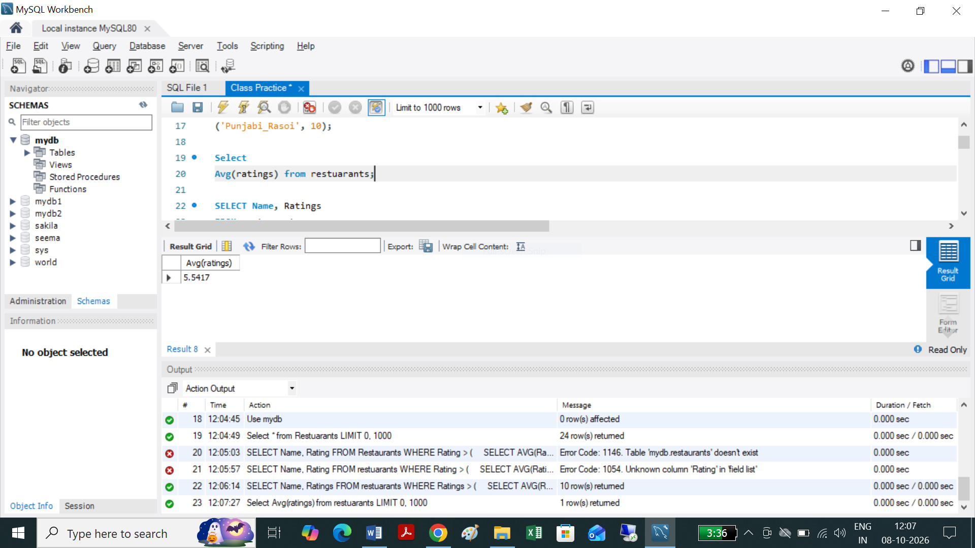

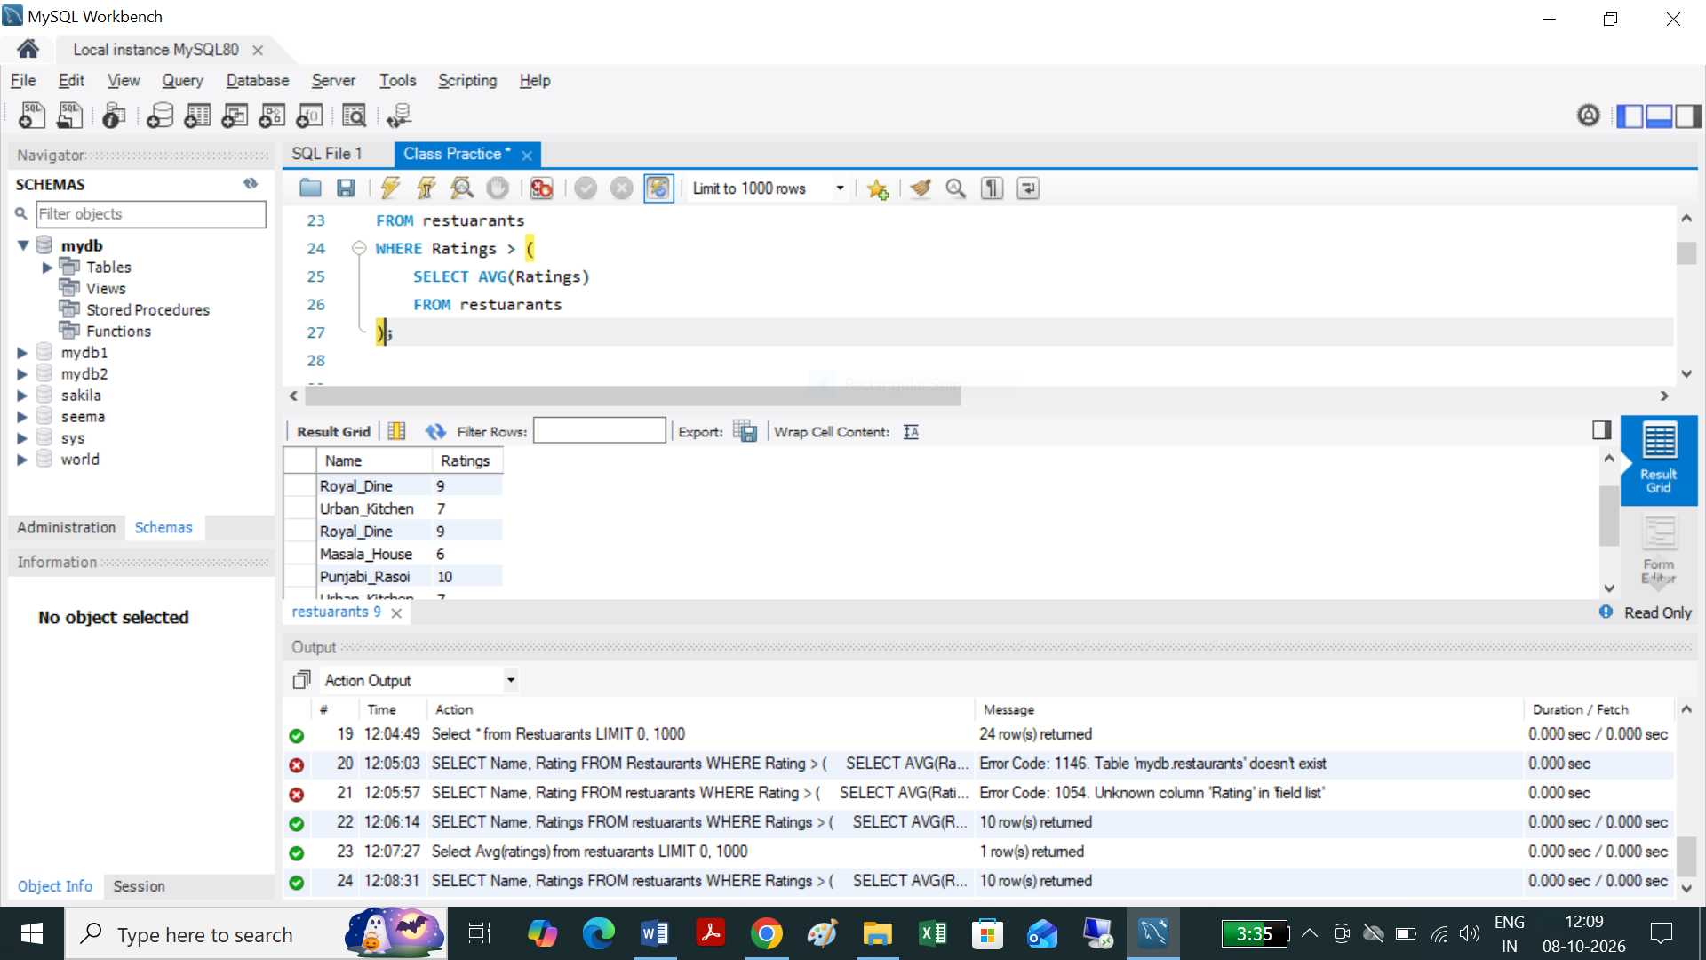
The subquery calculates the average rating of all restaurants, and the outer query displays only restaurants whose rating is higher than that average.
For this sample data, the average rating is 5.5, so restaurants with ratings above 5.5 will be displayed.


# Task 2:



Create table Products
(product_id INT,
Name Varchar(100),
price Decimal (10,2),
Category Varchar (50));

Select * from Products;

Insert into Products (Product_id, Name, Price , Category)
Values
(101, 'iPhone 14', 69999, 'Mobiles'),
(102, 'Samsung Galaxy S23', 74999, 'Mobiles'),
(103, 'OnePlus 11', 56999, 'Mobiles'),
(104, 'HP Laptop', 54999, 'Laptops'),
(105, 'Dell Inspiron', 62999, 'Laptops'),
(106, 'Lenovo IdeaPad', 48999, 'Laptops'),
(107, 'Boat Headphones', 1999, 'Audio'),
(108, 'Sony Headphones', 4999, 'Audio'),
(109, 'JBL Earbuds', 2999, 'Audio'),
(110, 'Nike Shoes', 5999, 'Footwear'),
(111, 'Adidas Shoes', 4999, 'Footwear');
Select
Name, Avg(Price),Category from Products group by Name, Category;

SELECT
p.name,
p.price,
p.category,
(
SELECT AVG(p2.price)
FROM Products p2
WHERE p2.category = p.category
) AS average_category_price
FROM Products p;

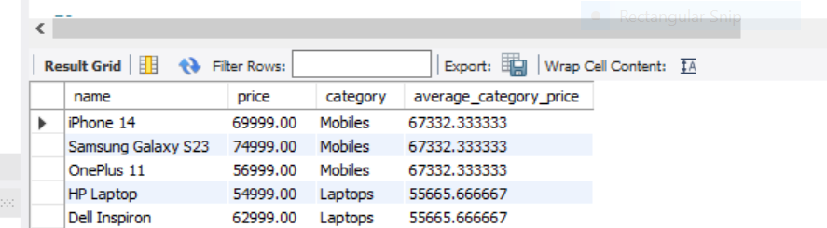

# Task 3:
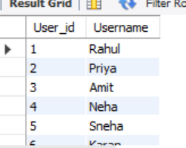
Select * from Users;
Create table Users
(User_id int,
Username Varchar (30));

Insert into Users
VALUES
(1,"Rahul"),
(2,"Priya"),
(3,"Amit"),
(4,"Neha"),
(5,"Sneha"),
(6,"Karan");

select * from users;

select * from Playlists;
Create Table Playlists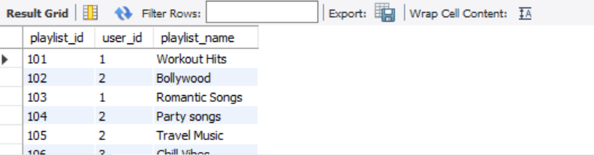

(playlist_id int,
user_id int,
playlist_name varchar (30));

Insert into Playlists
VALUES (101,1,"Workout Hits"),
(102,2,"Bollywood"),
(103,1,"Romantic Songs"),
(104, 2, "Party songs"),
(105, 2, "Travel Music"),
(106,3,"Chill Vibes"),
(107,3, "Morning music"),
(108,3,"Study Music"),
(109,3,"Favorites"),
(110,4,"Bollywood Hits"),
(111,5,"Relaxing music"),
(112,5,"Punjabi songs"),
(113,6,"Old Classics");
select * from Playlists;
SELECT
u.username,
p.playlist_count
FROM Users u
JOIN (
SELECT
user_id,
COUNT(*) AS playlist_count
FROM Playlists
GROUP BY user_id
) p
ON u.user_id = p.user_id
WHERE p.playlist_count > (
SELECT AVG(playlist_count)
FROM (
SELECT
user_id,
COUNT(*) AS playlist_count
FROM Playlists
GROUP BY user_id
) AS playlist_counts
);


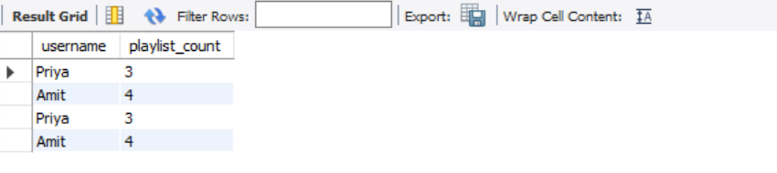

# Task 4:
use mydb;
Select * from Orders;
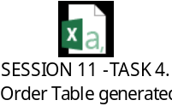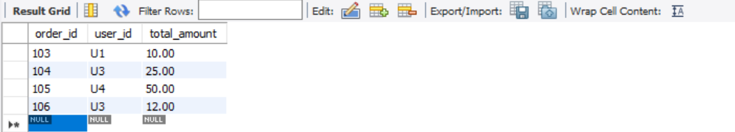
CREATE TABLE Orders
(order_id INT PRIMARY KEY,
user_id VARCHAR(50) NOT NULL,
total_amount DECIMAL(10, 2) NOT NULL
);

INSERT INTO Orders (order _id, user _id, total _amount)
VALUES
(101, 'U1', 15.00),
(102, 'U2', 40.00),
(103, 'U1', 10.00),
(104, 'U3', 25.00),
(105, 'U4', 50.00),
(106, 'U3', 12.00);

SELECT DISTINCT user_id
FROM Orders
WHERE total_amount > (
SELECT AVG(total_amount)
FROM Orders
);

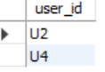
SESSION 12:

# Task 1:
use mydb;
create table SpotifyArtists
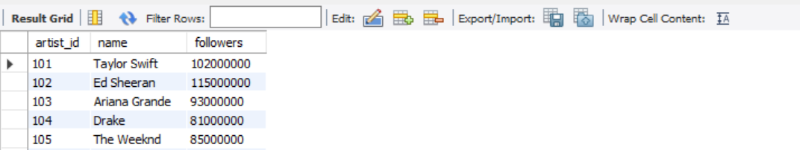
(artist_id INT PRIMARY KEY,
name VARCHAR(255) NOT NULL,
followers INT NOT NULL);

select * from spotifyartists;

Insert into Spotifyartists
values (101, 'Taylor Swift', 102000000),
(102, 'Ed Sheeran', 115000000),
(103, 'Ariana Grande', 93000000),
(104, 'Drake', 81000000),
(105, 'The Weeknd', 85000000),
(106, 'Billie Eilish', 88000000);


WITH TopArtists AS (
SELECT
artist_id,
name,
followers
FROM
SpotifyArtists
ORDER BY
followers DESC
LIMIT 3
)
SELECT
artist_id,
name,
followers
FROM
TopArtists;
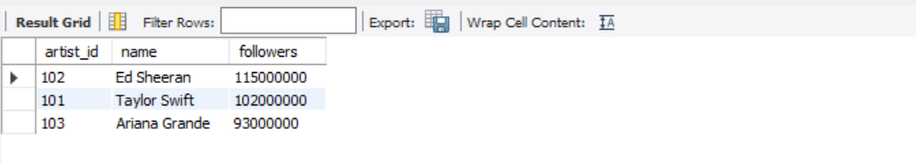

# TASK 2:

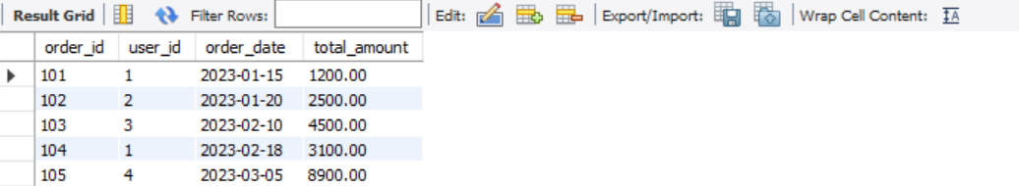
use mydb;
CREATE TABLE FlipkartOrders (
order_id INT PRIMARY KEY,
user_id INT,
order_date DATE,
total_amount DECIMAL(10, 2)
);
select * from flipkartorders;
-- Insert Sample Data for 2023
INSERT INTO FlipkartOrders (order_id, user_id, order_date, total_amount) VALUES
(101, 1, '2023-01-15', 1200.00),
(102, 2, '2023-01-20', 2500.00),
(103, 3, '2023-02-10', 4500.00),
(104, 1, '2023-02-18', 3100.00),
(105, 4, '2023-03-05', 8900.00), -- Highest Month (March: 8900 + 1200 = 10100)
(106, 2, '2023-03-22', 1200.00),
(107, 5, '2023-04-12', 3400.00),
(108, 3, '2023-05-01', 5600.00),
(109, 2, '2023-11-11', 7800.00),
(110, 4, '2023-12-25', 4300.00);

WITH MonthlyTotals AS (
SELECT
EXTRACT(MONTH FROM order_date) AS order_month,
SUM(total_amount) AS total_sales
FROM
FlipkartOrders
WHERE
EXTRACT(YEAR FROM order_date) = 2023
GROUP BY
EXTRACT(MONTH FROM order_date)
)
SELECT
order_month,
total_sales
FROM
MonthlyTotals
ORDER BY
total_sales DESC
LIMIT 1;
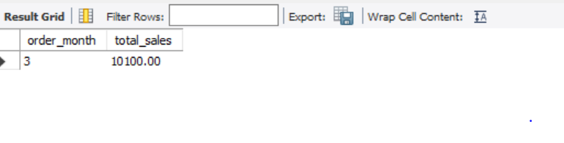
# TASK 3:
Create the CalendarDays table structure C
REATE TABLE CalendarDays ( id SERIAL PRIMARY KEY, day_date DATE NOT NULL ); --
Populate the CalendarDays table using the recursive CTE
INSERT INTO CalendarDays (day_date) WITH RECURSIVE DateGenerator AS ( SELECT CURRENT_DATE AS day_date, 1 AS level UNION ALL SELECT (day_date + INTERVAL '1 day')::DATE, level + 1 FROM DateGenerator WHERE level < 7 )
SELECT day_date FROM DateGenerator; -- Verify the dataset SELECT * FROM CalendarDays;
WITH RECURSIVE CalendarDays AS ( -- Anchor member: Starts with the current date SELECT CURRENT_DATE AS day_date, 1 AS level
UNION ALL –
Recursive member: Adds 1 day until reaching 7 days total SELECT (day_date + INTERVAL '1 day')::DATE, level + 1 FROM CalendarDays WHERE level < 7 ) –
Select the generated dates from the CTE SELECT day_date FROM CalendarDays;

# TASK 4:
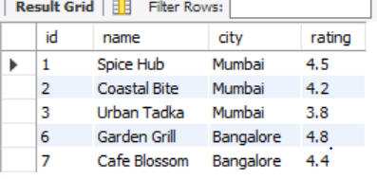

use mydb;  
Select * from Zomatorestaurants;
CREATE TABLE ZomatoRestaurants (
id INT PRIMARY KEY,
name VARCHAR(100),
city VARCHAR(50),
rating DECIMAL(2, 1));
-- Step 2: Insert Sample Data
INSERT INTO ZomatoRestaurants (id, name, city, rating) VALUES
(1, 'Spice Hub', 'Mumbai', 4.5),
(2, 'Coastal Bite', 'Mumbai', 4.2),
(3, 'Urban Tadka', 'Mumbai', 3.8),
(4, 'Delhi Bistro', 'Delhi', 3.9),
(5, 'Royal Curry', 'Delhi', 3.5),
(6, 'Garden Grill', 'Bangalore', 4.8),
(7, 'Cafe Blossom', 'Bangalore', 4.4);

Select * from Zomatorestaurants;

WITH CityAvgRating AS (
SELECT
city,
AVG(rating) AS avg_city_rating
FROM ZomatoRestaurants
GROUP BY city
HAVING AVG(rating) > 4.0)
SELECT
r.id,
r.name,
r.city,
r.rating
FROM ZomatoRestaurants r
JOIN CityAvgRating c ON r.city = c.city;

TASK 5:

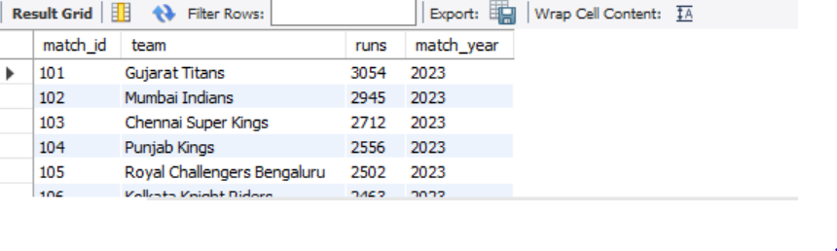
Use mydb;
Select * from IPLMatches;
CREATE TABLE IPLMatches (
match_id INT,
team VARCHAR(50),
runs INT,
match_year INT
);
-- 2. Insert sample aggregations / total runs for IPL 2023 season
INSERT INTO IPLMatches (match_id, team, runs, match_year) VALUES
(101, 'Gujarat Titans', 3054, 2023),
(102, 'Mumbai Indians', 2945, 2023),
(103, 'Chennai Super Kings', 2712, 2023),
(104, 'Punjab Kings', 2556, 2023),
(105, 'Royal Challengers Bengaluru', 2502, 2023),
(106, 'Kolkata Knight Riders', 2463, 2023),
(107, 'Rajasthan Royals', 2419, 2023),
(108, 'Sunrisers Hyderabad', 2376, 2023),
(109, 'Lucknow Super Giants', 2354, 2023),
(110, 'Delhi Capitals', 2182, 2023);

Select * from IPLMatches;

WITH TeamRuns2023 AS (
SELECT
team,
SUM(runs) AS total_runs
FROM
IPLMatches
WHERE
match_year = 2023
GROUP BY
team
)
SELECT
team,
total_runs
FROM
TeamRuns2023
WHERE
total_runs > 2000
ORDER BY
total_runs DESC;
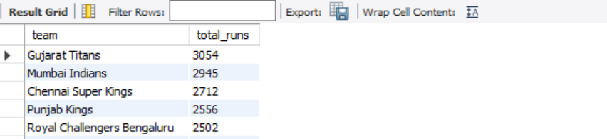

SESSION 13
# TASK 1:
use mybd;
Select * from Orders;
CREATE TABLE Orders
(order_id INT PRIMARY KEY,
user_id INT NOT NULL,
order_amount DECIMAL(10, 2) NOT NULL,
app_name VARCHAR(50) NOT NULL
);

-- 2. Insert sample dataset (10 records)
INSERT INTO Orders (order_id, user_id, order_amount, app_name) VALUES
(101, 1, 450.00, 'Zomato'),
(102, 2, 1200.50, 'Flipkart'),
(103, 1, 280.00, 'Swiggy'),
(104, 3, 3500.00, 'Flipkart'),
(105, 4, 150.00, 'Zomato'),
(106, 2, 620.00, 'Swiggy'),
(107, 5, 890.00, 'Zomato'),
(108, 3, 210.00, 'Swiggy'),
(109, 6, 4500.00, 'Flipkart'),
(110, 4, 310.00, 'Zomato');

Select * from Orders;
use mydb;

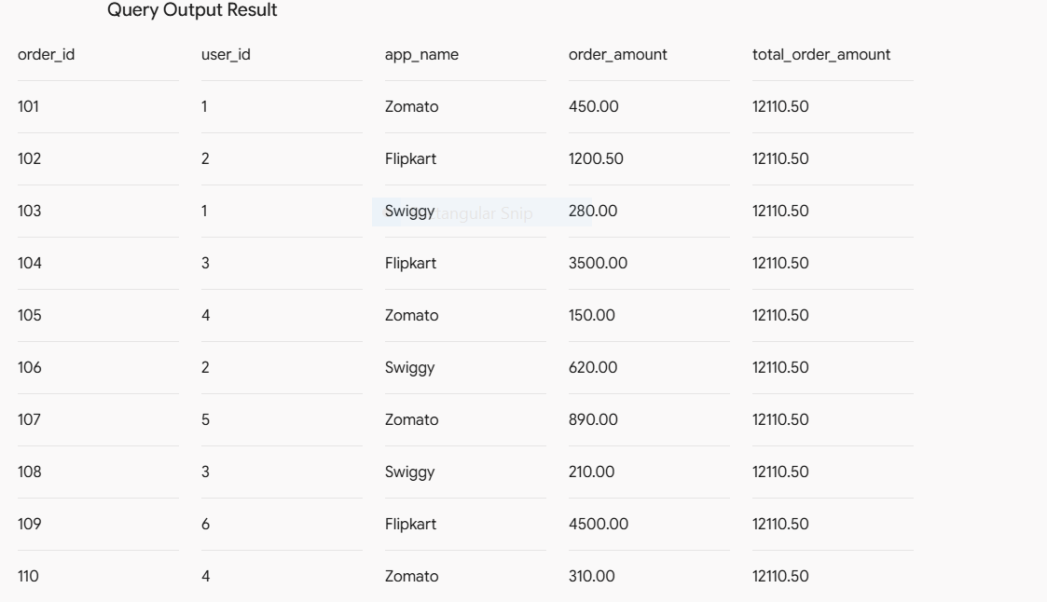

# TASK 2:
use mydb;
select * from Ord;
CREATE TABLE Ord (
order_id INT PRIMARY KEY,
user_id INT NOT NULL,
order_amount DECIMAL(10, 2) NOT NULL
);

-- Insert sample data
INSERT INTO Ord (order_id, user_id, order_amount) VALUES
(101, 1, 100.00),
(102, 1, 200.00),
(103, 2, 50.00),
(104, 2, 150.00),
(105, 2, 100.00),
(106, 3, 300.00);

Select
order_id,
user_id,
order_amount,
AVG(order_amount) OVER (PARTITION BY user_id) AS avg_user_order_amount
FROM
Ord;

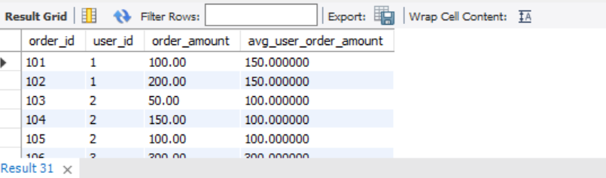

# TASK 3:
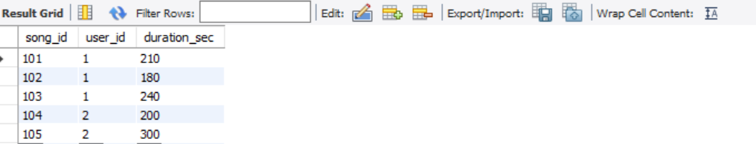

use mydb;
select * from Musiclists;
CREATE TABLE Musiclists (
song_id INT PRIMARY KEY,
user_id INT NOT NULL,
duration_sec INT NOT NULL
);
-- Insert sample records
INSERT INTO Musiclists (song_id, user_id, duration_sec)
VALUES
(101, 1, 210),
(102, 1, 180),
(103, 1, 240),
(104, 2, 200),
(105, 2, 300);
SELECT
song_id,
user_id,
duration_sec,
SUM(duration_sec) OVER (PARTITION BY user_id) AS total_user_duration_sec

FROM
musiclists;

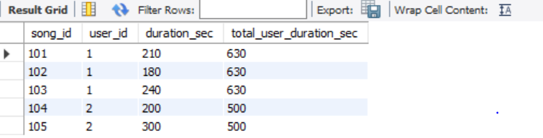

# TASK 4:
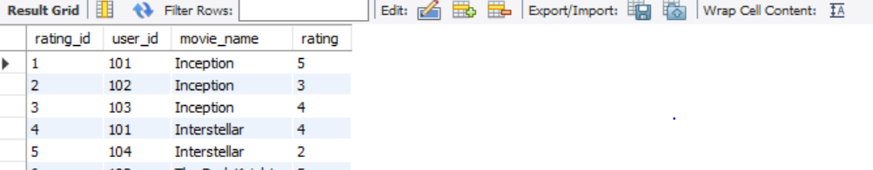
use mydb;
Select * from Movieratings;
CREATE TABLE MovieRatings (
rating_id INT PRIMARY KEY,
user_id INT NOT NULL,
movie_name VARCHAR(255) NOT NULL,
rating INT CHECK (rating BETWEEN 1 AND 5)
);

-- Insert sample data
INSERT INTO MovieRatings (rating_id, user_id, movie_name, rating) VALUES
(1, 101, 'Inception', 5),
(2, 102, 'Inception', 3),
(3, 103, 'Inception', 4),
(4, 101, 'Interstellar', 4),
(5, 104, 'Interstellar', 2),
(6, 102, 'The Dark Knight', 5),
(7, 103, 'The Dark Knight', 5);
Select * from Movieratings;

Select
rating_id,user_id, movie_name,rating,
Avg(rating)Over(partition by movie_name) as Avg_movie_rating,
rating - AVG(rating) OVER(PARTITION BY movie_name) AS rating_difference
FROM
MovieRatings;

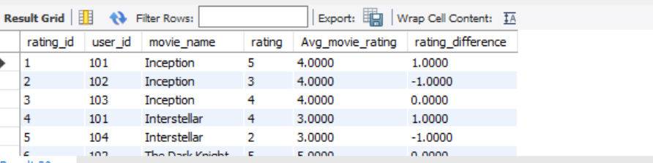

SESSION 14:
TASK 1:
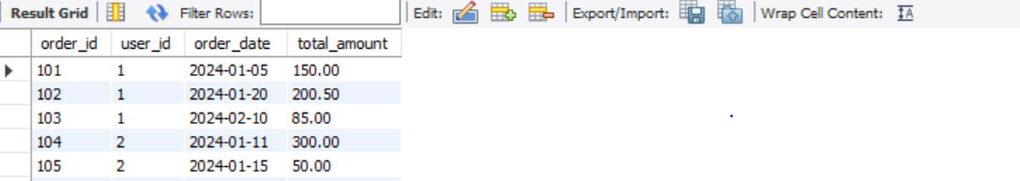
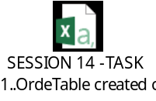
use mydb;
select * from Orde;
CREATE TABLE Orde (
order_id INT PRIMARY KEY,
user_id INT NOT NULL,
order_date DATE NOT NULL,
total_amount DECIMAL(10, 2) NOT NULL
);
INSERT INTO Orde (order_id, user_id, order_date, total_amount) VALUES
(101, 1, '2024-01-05', 150.00),
(102, 1, '2024-01-20', 200.50),
(103, 1, '2024-02-10', 85.00),
(104, 2, '2024-01-11', 300.00),
(105, 2, '2024-01-15', 50.00),
(106, 3, '2024-03-01', 420.00);

select order_id,user_id,order_date,total_amount,
Row_number( )over(Partition by User_id
order by order_date desc) AS user_order_seq
FROM Orde;



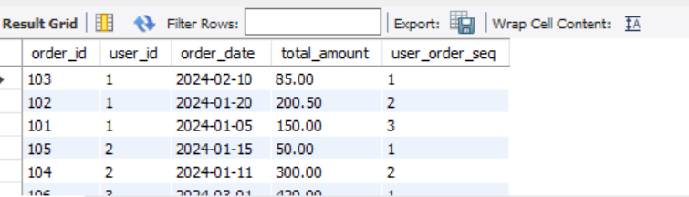

# TASK 2:

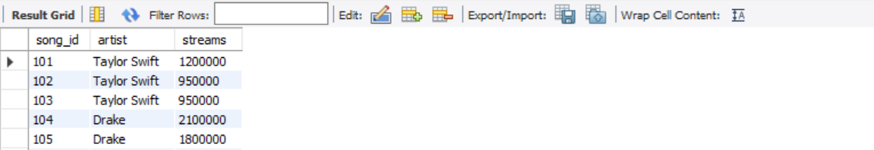
Use mydb;
Select * from songs;
CREATE TABLE Songs (
song_id INT PRIMARY KEY,
artist VARCHAR(100) NOT NULL,
streams INT NOT NULL
);

INSERT INTO Songs (song_id, artist, streams) VALUES
(101, 'Taylor Swift', 1200000),
(102, 'Taylor Swift', 950000),
(103, 'Taylor Swift', 950000),
(104, 'Drake', 2100000),
(105, 'Drake', 1800000),
(106, 'Drake', 1500000);

SELECT
Song_id,
artist,
streams,
Rank() over (Partition by artist order by streams desc) as song_rank
FROM Songs;
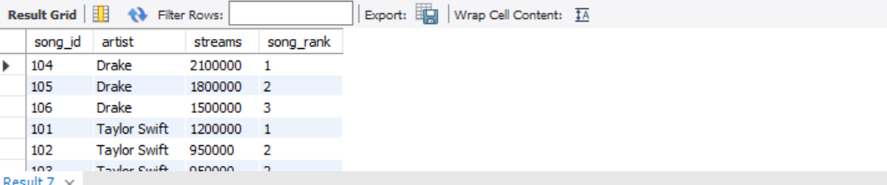

# TASK 3:



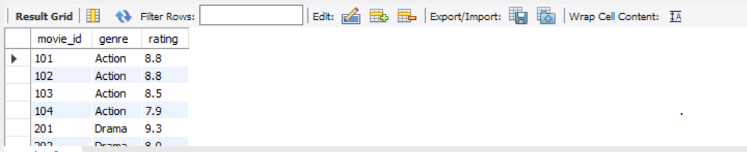

Use mydb;
select * from movies;
CREATE TABLE Movies (
movie_id INT PRIMARY KEY,
genre VARCHAR(50) NOT NULL,
rating DECIMAL(3, 1) NOT NULL
);

-- Insert sample records
INSERT INTO Movies (movie_id, genre, rating) VALUES
(101, 'Action', 8.8),
(102, 'Action', 8.8),
(103, 'Action', 8.5),
(104, 'Action', 7.9),
(201, 'Drama', 9.3),
(202, 'Drama', 8.9),
(203, 'Drama', 8.9),
(204, 'Drama', 8.1);

Select movie_id, genre, rating , dense_rank ()over(Partition by genre Order by rating desc) as rating_rank from Movies;

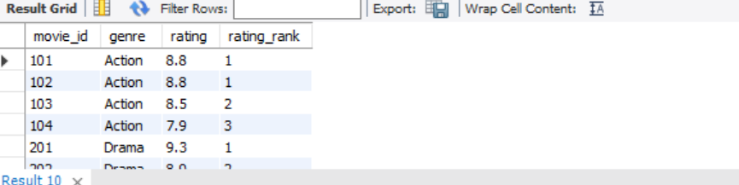

# TASK 4:
With RankedInfluencers as (Select id,platform, followers, Row_Number()over(partition by platform order by followers desc) as row_num from influencers)
SELECT
id,
platform,
followers,
row_num
FROM RankedInfluencers
WHERE row_num <= 3;

SESSION 15:

TASK 1:
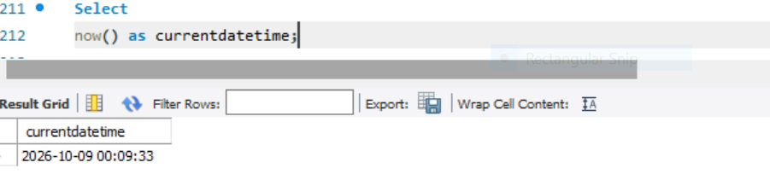

TASK 2:
use mydb;
select * from Orders;
select
Order_date,
year(order_date) as Order_year,
month(order_date) as Order_month,
day(order_date)
as Order_day from Orders;

TASK 3:
SELECT Delivery_date,
Date_sub(delivery_date, interval 2 day) as Expected_pickup_date from deliveries;

TASK 4:
Select
User_id, Start_date, end, Dated IFF(Start_date, end_date) as
total _days from subscriptions;

TASK 5:
Select
User_id, last_login_date from Applogins
Where Datediff(Now(), last_login_date ) >30;

# Session 16:
Task 1:
SELECT CONCAT(first_name, ' ', last_name) AS full_name
FROM users;
Explanation: The CONCAT() function combines first_name and last_name with a space between them. The AS full_name gives the result column the name full_name.

Task 2:
SELECT UPPER(song_title)
FROM playlists;
Explanation: The UPPER() function converts all song titles in the song_title column to uppercase letters.

Task 3:
SELECT TRIM(item_code) AS item_code
FROM food_items;
Explanation: The TRIM() function removes leading and trailing spaces from the item_code values. The AS item_code keeps the output column name as item_code.

Task 4:
SELECT RIGHT(imdb_id, 7) AS movie_number
FROM movies;
Explanation: The RIGHT(imdb_id, 7) function extracts the last 7 characters from the imdb_id column. The AS movie_number renames the output column to movie_number.

Task 5:
SELECT REPLACE(sku_code, '-', '_') AS sku_code
FROM products;
Explanation: The REPLACE() function replaces all dashes (-) in sku_code with underscores (_) and displays the updated codes.

# Session 17:
Task 1:
.Write an SQL query using CASE WHEN to classify orders in a 'FoodOrders' table as 'Small', 'Medium', or 'Large' based on the total_amount: 'Small' for less than 300, 'Medium' for 300 to 999, and 'Large' for 1000 and above.

SELECT
*,
CASE
WHEN total_amount < 300 THEN 'Small'
WHEN total_amount BETWEEN 300 AND 999 THEN 'Medium'
WHEN total_amount >= 1000 THEN 'Large'
END AS order_category
FROM FoodOrders;
Explanation:
The CASE WHEN statement classifies orders based on their total_amount.
- Small: Amount less than 300.
- Medium: Amount between 300 and 999.
- Large: Amount 1000 or above.
The order_category column displays the category assigned to each order.

Task 2:
.Given a 'Movies' table with a 'rating' column (out of 10), write an SQL query that adds a new column 'popularity' which shows 'Blockbuster' for ratings 8 and above, 'Hit' for 5 to
7.9, and 'Average' for below 5 using CASE WHEN ELSE END.

SELECT
*,
CASE
WHEN rating >= 8 THEN 'Blockbuster'
WHEN rating >= 5 THEN 'Hit'
ELSE 'Average'
END AS popularity
FROM Movies;
Explanation:
The CASE WHEN ELSE END statement classifies movies according to their ratings out of 10.
- Blockbuster: Rating 8 or above.
- Hit: Rating 5 to 7.9.
- Average: Rating below 5.
The popularity column displays the popularity category assigned to each movie.

Task 3:
.For a 'FlipkartProducts' table with a 'price' column, write an SQL query to create a
'price_category' column that bins prices as 'Budget' (below 500), 'Standard' (500 to 2000), and 'Premium' (above 2000) using CASE WHEN.

SELECT
*,
CASE
WHEN price < 500 THEN 'Budget'
WHEN price BETWEEN 500 AND 2000 THEN 'Standard'
ELSE 'Premium'
END AS price_category
FROM FlipkartProducts;
Explanation:
The CASE WHEN statement classifies products into three categories based on their prices.
- Budget: Price below ₹500.
- Standard: Price between ₹500 and ₹2000 (inclusive).
- Premium: Price above ₹2000.
The price_category column displays the category assigned to each product.

Task 4:
Write an SQL query for a 'SpotifyTracks' table that uses CASE WHEN to assign a 'duration_label' column: 'Short' for tracks under 180 seconds, 'Medium' for 180-300 seconds, and 'Long' for over 300 seconds.<br><br><em><strong>Hint:</strong> Use multiple WHEN conditions to cover all possible durations.</em>

SELECT
*,
CASE
WHEN duration < 180 THEN 'Short'
WHEN duration BETWEEN 180 AND 300 THEN 'Medium'
WHEN duration > 300 THEN 'Long'
END AS duration_label
FROM SpotifyTracks;
Explanation:
The CASE WHEN statement classifies tracks into three categories based on their duration in seconds.
- Short: Tracks with a duration under 180 seconds.
- Medium: Tracks with a duration between 180 and 300 seconds (inclusive).
- Long: Tracks with a duration over 300 seconds.
The duration_label column displays the category assigned to each track.

# Session 18:
Task 1:
Create a SQL view named TopRatedRestaurants that selects the restaurant name, average rating, and total number of reviews from a table of Zomato-style restaurant reviews, showing only restaurants with an average rating above 4.0.

CREATE VIEW TopRatedRestaurants AS SELECT restaurant_name,
AVG(rating) AS average_rating,
COUNT(*) AS total_reviews
FROM RestaurantReviews
GROUP BY restaurant_name
HAVING AVG(rating) > 4.0;
Explanation:
- CREATE VIEW: Creates a view named TopRatedRestaurants.
- AVG(rating): Calculates the average rating of each restaurant.
- COUNT(*): Counts the total number of reviews for each restaurant.
- GROUP BY restaurant_name: Groups reviews by restaurant name.
- HAVING AVG(rating) > 4.0: Displays only restaurants with an average rating above 4.0.
Result: The view displays each qualifying restaurant's name, average rating, and total number of reviews.

Task 2:
Update the TopRatedRestaurants view to also include the city column from the original restaurants table by joining the relevant tables.<br><br><em><strong>Hint:</strong> Use an INNER JOIN to combine data from both tables in your view definition.</em> CREATE OR REPLACE VIEW TopRatedRestaurants AS

SELECT
r.restaurant_name,
r.city,
AVG(rv.rating) AS average_rating,
COUNT(*) AS total_reviews
FROM Restaurants r
INNER JOIN RestaurantReviews rv
ON r.restaurant_name = rv.restaurant_name
GROUP BY
r.restaurant_name,
r.city
HAVING AVG(rv.rating) > 4.0;
Explanation:
- CREATE OR REPLACE VIEW: Updates the existing view definition.
- INNER JOIN: Combines the Restaurants and RestaurantReviews tables using the restaurant name.
- r.city: Includes the city of each restaurant.
- AVG(rv.rating): Calculates the average rating.
- COUNT(*): Counts the total number of reviews.
- GROUP BY: Groups the results by restaurant name and city.
- HAVING AVG(rv.rating) > 4.0: Shows only restaurants with an average rating above
4.0.
Result: The updated view displays the restaurant name, city, average rating, and total number of reviews for restaurants rated above 4.0.

Task 3:
. Try to update the average rating column directly through the TopRatedRestaurants view and observe what error or limitation occurs. Write down the exact error message and explain why this happens based on SQL view limitations.

UPDATE TopRatedRestaurants
SET average_rating = 4.5
WHERE restaurant_name = 'ABC Restaurant';
Error Message:
In MySQL, this operation typically produces an error similar to: ERROR 1348 (HY000): Column 'average_rating' is not updatable
Explanation:
The TopRatedRestaurants view contains the AVG(rating) aggregate function and uses GROUP BY and HAVING. Such views are not updatable in MySQL because the average_rating column is a calculated value derived from multiple rows in the original RestaurantReviews table.
To change the average rating, the underlying review records must be updated instead, where appropriate. The average rating will then be recalculated when the view is queried.

Task 4:
Create a view called DailyOrderSummary that shows, for each date, the total number of food orders and the total revenue from a Swiggy-style orders table. Ensure the view only includes dates from the last 30 days.<br><br><em><strong>Constraint:</strong> Use WHERE and GROUP BY clauses in your view definition.</em>

CREATE VIEW DailyOrderSummary AS
SELECT
DATE(order_date) AS order_day,
COUNT(*) AS total_orders,
SUM(total_amount) AS total_revenue
FROM FoodOrders
WHERE order_date >= CURRENT_DATE - INTERVAL 30 DAY
GROUP BY DATE(order_date);
Explanation:
  - CREATE VIEW: Creates a view named DailyOrderSummary.
  - DATE(order_date): Extracts the date from the order date and time.
  - COUNT(*): Calculates the total number of food orders per day.
  - SUM(total_amount): Calculates the total revenue per day.
  - WHERE: Filters orders from the last 30 days.
  - GROUP BY: Groups orders by date.
Result: The view displays each date, the total number of orders, and the total revenue for that date over the last 30 days.

Task 5:
List 3 good practices you should follow when creating SQL views for analytics dashboards, and for each, give a one-line example related to a Flipkart sales reporting scenario.

- Use Meaningful Column Names: Choose clear and descriptive column names so that dashboard users can easily understand the data.
Example: In a Flipkart sales reporting view, use total_revenue instead of a confusing name like SUM1.
- Filter Unnecessary Data: Use the WHERE clause to include only relevant records and improve dashboard performance.
Example: Create a Flipkart sales view that includes only completed orders using WHERE order_status = 'Completed'.
- Avoid Unnecessary Complexity: Keep views simple and avoid excessive joins or calculations that may slow down dashboard queries.
Example: Create a Flipkart sales view that summarizes total sales by product category using GROUP BY product_category.

# Session 19:
Task 1:
Run a SELECT query on a large 'orders' table (at least 10,000 rows) to find all orders for a specific user_id and measure the query execution time.

SET @start_time = NOW(6);

SELECT *
FROM orders
WHERE user_id = 101;

SET @end_time = NOW(6);

SELECT
TIMESTAMPDIFF(
MICROSECOND,
@start_time,
@end_time
) / 1000 AS execution_time_ms;
Explanation:
- NOW(6) records the start and end timestamps with microsecond precision.
- SELECT * FROM orders WHERE user_id = 101 retrieves all orders belonging to user ID 101.
- TIMESTAMPDIFF() calculates the elapsed time in milliseconds.
- The orders table should contain at least 10,000 rows to meet the assignment requirement.
Result: The query displays all orders for user ID 101 and reports the elap

Task 2:
Create an index on the user_id column of the 'orders' table and re-run the same SELECT query to measure the new execution time.<br><br><em><strong>Hint:</strong> Use CREATE INDEX idx_user_id ON orders(user_id); and compare the times before and after.</em>

CREATE INDEX idx_user_id
ON orders(user_id);
Run the SELECT Query Again:
SET @start_time = NOW(6);

SELECT *
FROM orders
WHERE user_id = 101;

SET @end_time = NOW(6);

SELECT
TIMESTAMPDIFF(
MICROSECOND,
@start_time,
@end_time
) / 1000 AS execution_time_ms;
Explanation:
- CREATE INDEX creates an index named idx_user_id on the user_id column.
- The SELECT query retrieves all orders belonging to user ID 101.
- The start and end timestamps measure the elapsed time in milliseconds.
- The index allows MySQL to locate matching rows more efficiently instead of scanning the entire table, depending on the query plan and data distribution.
Comparison of Execution Time:
Before Index After Index
Record the execution time before creating the Record the execution time after creating the index. index.
May require a full table scan. May use the index to find matching rows.
Conclusion: Creating an index on user_id can improve query performance. Actual execution times depend on the table size, data distribution, caching, and database configuration.

Task 3:
Use the EXPLAIN PLAN command to analyze how your SELECT query runs before and after adding the index, and write down the key differences you observe in the output.

EXPLAIN
SELECT *
FROM orders
WHERE user_id = 101;
SQL Query (After Creating the Index):
CREATE INDEX idx_user_id
ON orders(user_id);

EXPLAIN
SELECT *
FROM orders
WHERE user_id = 101;
Explanation:
The EXPLAIN command shows how MySQL plans to execute a query. By comparing the output before and after creating the index, we can identify changes in query performance.
Key Differences Observed:
Before Index After Index
type may be ALL, indicating a full table type may be ref or range, indicating indexscan. based access.
key is usually NULL. key may show idx_user_id.
rows may show a large number of rows to rows may show fewer rows to examine.
examine.
Query may take more time. Query may execute faster.
Conclusion:
Creating an index on user_id can reduce the number of rows MySQL examines and improve query performance. The actual output depends on the table's data and the query optimizer's decisions.

Task 4:
Write a query for a 'products' table that avoids a full table scan by using an index on the 'category' column to fetch all products in a specific category.

CREATE INDEX idx_category
ON products(category);

SELECT *
FROM products
WHERE category = 'Electronics';
Explanation:
- CREATE INDEX creates an index named idx_category on the category column.
- WHERE category = 'Electronics' retrieves all products belonging to the Electronics category.
- MySQL can use the index to locate matching products without scanning the entire table, depending on the query optimizer and data distribution.
Conclusion:
Creating an index on the category column can improve query performance by reducing the number of rows examined. Use EXPLAIN to verify whether MySQL uses the index instead of performing a full table scan.

Task 5:
Suppose your SELECT query on the 'orders' table is still slow even after adding an index. Use EXPLAIN PLAN and research at least one more optimization technique (other than indexing) using an AI tool like ChatGPT or Copilot, and describe how you would apply it.

EXPLAIN
SELECT *
FROM orders
WHERE user_id = 101;
Explanation:
The EXPLAIN command helps analyze how MySQL executes a query. If the query is still slow after adding an index, we can check the number of rows examined, the access type, and whether the index is being used.
Optimization Technique: Avoid Using SELECT *
One optimization technique, other than indexing, is to select only the required columns instead of retrieving every column from the table.
Optimized SQL Query:
SELECT order_id, order_date, total_amount
FROM orders
WHERE user_id = 101;
How This Improves Performance:
- It retrieves only the necessary columns.
- It reduces the amount of data transferred from the database.
- It can reduce memory usage and improve query response time, especially when the table contains many columns or large values.
Conclusion:
Using EXPLAIN helps identify query performance issues. Selecting only the required columns instead of using SELECT * is an effective optimization technique that can improve performance even when an index already exists.

